**Lecture # 17:**

**Objective:**

* Database Connectivity (CONNECTED)
  + Update Delete Example

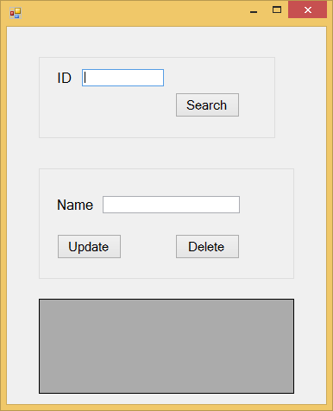View Data From Database (simple)

Presentation Layer

namespace Searchdeleteupdate_1layer

{

public partial class Form1 : Form

{

SqlConnection sqlcon = null; SqlCommand sqlcmd = null;

string strcon = @"Integrated Security=SSPI;Persist Security Info=False;Initial Catalog=student;Data Source=ATECH\SQLEXPRESS";

string query = ""; SqlDataReader sdr = null; public Form1()

{

InitializeComponent();

}

private void button1_Click(object sender, EventArgs e)

{

sqlcon = new SqlConnection(strcon); sqlcon.Open();

query = "select * from stdinfo where ID='"+textBox1.Text+"'"; sqlcmd = new SqlCommand(query, sqlcon); sdr=sqlcmd.ExecuteReader();

while (sdr.Read())

{

dataGridView1.Rows.Add(textBox1.Text[0],textBox2.Text[1]);

}

}

private void button2_Click(object sender, EventArgs e)

{

sqlcon = new SqlConnection(strcon); sqlcon.Open();

query = "update stdinfo set name='"+textBox2.Text+"' where id='"+textBox1.Text+"'";

sqlcmd = new SqlCommand(query, sqlcon); sqlcmd.ExecuteNonQuery();

}

private void button3_Click(object sender, EventArgs e)

{

sqlcon = new SqlConnection(strcon); sqlcon.Open();

query = "delete from stdinfo where name='" + textBox2.Text + "'"; sqlcmd = new SqlCommand(query, sqlcon);

sqlcmd.ExecuteNonQuery();

}

}

}